WELCOME!
This survey is meant to study the wishes of tourists and make them as happy as possible during their trip. Every piece of information you share will be valuable to us. Please answer as thoroughly as you can to help us. There are no right or wrong answers. We are not interested in the “best destinations,” but in your actual choices, even if they are impulsive or not well planned. The answers are anonymous and will be used only for research purposes.There are 10 simple questions (hopefully also fun ones), but it is important that you have at least ten minutes to answer them—so if you don’t have time now, please come back when you can dedicate a moment to us!

PAST TRIPS
- Tell us about a trip of yours that you were not satisfied with. What would you not do again, especially in the planning phase? (OPEN-ENDED QUESTION)
- Which trip or vacation best represents your way of choosing how to travel? Tell us about the destination: how you chose it, why it reflects you, etc. (OPEN-ENDED QUESTION)

ORGANIZING A VACATION
- Imagine organizing a vacation. Sketch a short story of your choice: what would be the 3–4 main scenes?
  - Scene 1 (OPEN-ENDED QUESTION)
  - Scene 2 (OPEN-ENDED QUESTION)
  - Scene 3 (OPEN-ENDED QUESTION)
  - Scene 4 (Optional) (OPEN-ENDED QUESTION)

MULTIPLE CHOICE
- Which of these stories represents you the most?
  - I see an offer, check very little, and book the same day.
  - I compare 3–4 destinations, read reviews, and book after a few days.
  - I check flexibility/free cancellation and decide when I find the right one.
  - Others.

ALTERNATIVE CHOICES
Look at the two alternatives and answer the following questions.
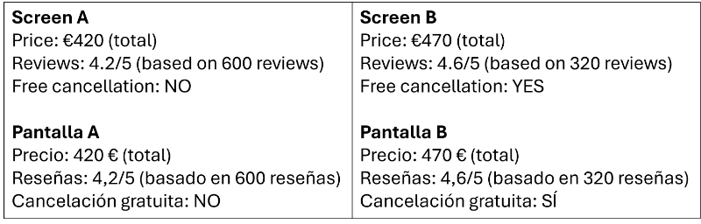

- If you had to choose right now, which of the two screens would you pick?
  - A.
  - B.
- Which was the decisive piece of information you looked at last before choosing? (OPEN-ENDED QUESTION)

SUGGESTIONS
- If you had to teach someone your method of choosing, which 3 fundamental steps would you tell them to follow?
  - Step 1 (OPEN-ENDED QUESTION)
  - Step 2 (OPEN-ENDED QUESTION)
  - Step 3 (OPEN-ENDED QUESTION)
- If instead you had to give 3 pieces of advice to your past self about organizing a vacation, what would you say?
  - Step 1 (OPEN-ENDED QUESTION)
  - Step 2 (OPEN-ENDED QUESTION)
  - Step 3 (OPEN-ENDED QUESTION)

OPEN QUESTIONS
- When you organized your last vacation, did you have a list of destinations in mind? How did you make your final choice? And among them, was there a destination you said, “No, this is not for me”? Tell us why. (OPEN-ENDED QUESTION)
- When did you feel you had “enough” information to decide? What made you stop searching? And if you had had more time, what would you have added to your research? (OPEN-ENDED QUESTION)
- Is there something important we haven’t asked you but that influenced your decision? Tell us about it. (OPEN-ENDED QUESTION)

ASCOLI PICENO (ADD PICTURE)
Ascoli Piceno is a historic city in central Italy, located about 2 hours from Rome and close to the Adriatic coast. It is famous for its medieval towers, Renaissance squares (such as Piazza del Popolo), local gastronomy (olive all’ascolana), and its well-preserved historic center surrounded by mountains and natural parks.
Reference map: Look at this map and continue to the next section. (ADD MAP)
PRICING
- Imagine a weekend package in Ascoli Piceno: it includes 2 nights in centrally located accommodation, 1 dinner at a restaurant, and 1 activity of your choice (for example: a museum, guided tour, etc.). Exclude transportation.
  - At what price would you consider the product to be priced so low that you would feel the quality couldn't be very good? In euros (€). (Space to put only numbers)
  - At what price would you consider the product to be a bargain - a great buy for the money? In euros (€). (Space to put only numbers)
  - At what price would you consider the product starting to get expensive, so that it is not out of the question, but you would have to give some thought to buying it? In euros (€). (Space to put only numbers)
  - At what price would you consider the product to be so expensive that you would not consider buying it? In euros (€). (Space to put only numbers)

TYPE OF TRAVELER
- When you travel, who takes care of organizing the trip?
  - Myself.
  - I organize it with others.
  - Someone else.
- What is your primary purpose for traveling? You can select up to 2 options.
  - See new cities or explore new destinations.
  - Relaxation.
  - Outdoor activities.
  - Cultural attractions.
  - Events: festivals, sports, etc.
- What type of trip do you usually choose: a short trip, a medium-length trip, or a long one? Please explain the reason for your choice. (OPEN-ENDED QUESTION)
- What type of traveler are you? You can select more than one. You can select up to 2 options.
  - Solo traveler.
  - Family traveler.
  - Group traveler.
  - Couple traveler.
- What is the first place you go to for travel information?
  - Google or similar.
  - ChatGPT or similar Ais.
  - Online Platforms as Booking.com.
  - Airbnb, TripAdvisor or similar.
  - Social media.
  - Official destination websites.
  - Travel Blogs.
  - Travel agencies.
  - Personal recommendations.
- What is your age group?
  - <25.
  - 25-35.
  - 35-59.
  - >60.
- Which is your gender?
  - Male.
  - Female.
  - Other/I prefer not to say it.
- Where do you live?
  - Italy.
  - Europe, excluding Italy.
  - Asia.
  - Africa.
  - Oceania.
  - North America.
  - Central America.
  - South America.
- What is your current occupation?
  - Employed.
  - Self-employed.
  - Student.
  - Retired.
  - Unemployed.
  - Other.

